Tab 1

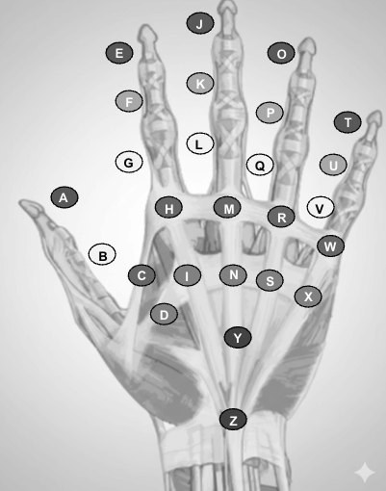
The patient was brought into the examination room for ultrasound-based mapping of Dupuytren’s Contracture using a 12 MHz ultrasound probe to evaluate the palmar aponeurosis, flexor tendons, and fascial planes on the Left hand. Systematic segmental measurements and images were obtained throughout 26 regions of the hand, mapping them out as a metric of disease severity. Baseline thickness and disease extent were recorded for each region. Mapped images were captured, labeled, and stored on the patient's chart for incorporation into the radiation treatment planning. The patient’s mapping was preparation for shielding and immobilization simulation. Fields are drawn on the color pictures below, but black and white are shown here for reference. See METHODS (below) for decision-making algorithm of areas to exclude from treatment.

PCP Impression: Rad Onc Impression:

Performed by: Performed by:
PCP DOS: _ Rad Onc DOS: _
Select Physician Select Physician
Primary Care Physician Radiation Oncologist
CureRays Radiation Medicine CureRays Radiation Medicine

300 Sierra College Drive, Suite 150
P: (530) 802-6400 F: (530) 274-6629
www.curerays.com

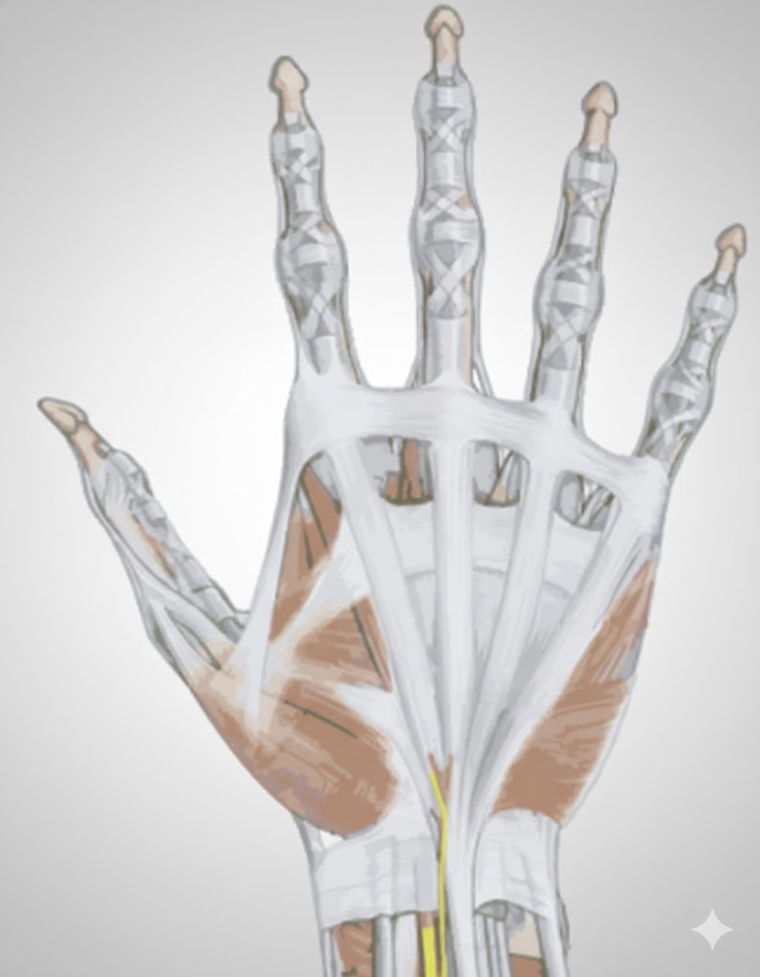


A
B
C
D
E
F
H
G
L
Q
V
I
J
K
M
N
O
P
R
S
T
U
W
X
Y
Z
Final Field Post-Ultrasound
Finalized Field by Radiation Oncologist

A
B
C
D
E
F
H
G
L
Q
V
I
J
K
M
N
O
P
R
S
T
U
W
X
Y
Z
Initial Field Pre-Ultrasound
Initial Field Proposed by Primary Care Physician

Zone | Zone Map | US Image | US Assessment  Distinct Facial Plane (Y/N)  Depth to Target (mm)  (PCP) | Palpation Assessment  (PCP) | Field Design Decision  (RAD ONC)
A | 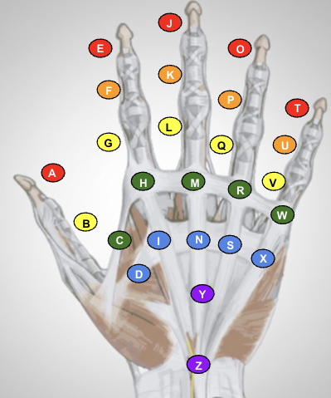 Distal 1st digit | US image not obtained  Objective for image:  1- Show a clear fascial plane above the tendon OR  2- Show the absence thereof | Is there a distinct and clear plane of fascia overlying the tendon?  Distinct Plane by US  If visible pathology,  Depth of target:  __ mm | Not Palpable  MD Notes: _ | Exclude  Exclude area from treatment only IF there is BOTH a distinct fascial plane over the tendon AND there is no palpable disease or clinical findings.
B | Proximal 1st digit | US image not obtained  Objective for image:  1- Show a clear fascial plane above the tendon OR  2- Show the absence thereof | Is there a distinct and clear plane of fascia overlying the tendon?  Distinct Plane by US  If visible pathology,  Depth of target:  __ mm | Not Palpable  MD Notes: _ | Exclude  Exclude area from treatment only IF there is BOTH a distinct fascial plane over the tendon AND there is no palpable disease or clinical findings.
C | 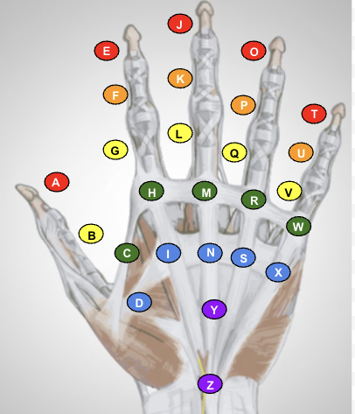Digit 1-2 webbing | US image not obtained  Objective for image:  1- Show a clear fascial plane above the tendon OR  2- Show the absence thereof | Is there a distinct and clear plane of fascia overlying the tendon?  Distinct Plane by US  If visible pathology,  Depth of target:  __ mm | Not Palpable  MD Notes: _ | Exclude  Exclude area from treatment only IF there is BOTH a distinct fascial plane over the tendon AND there is no palpable disease or clinical findings.
D |  Thenar | US image not obtained  Objective for image:  1- Show a clear fascial plane above the tendon OR  2- Show the absence thereof | Is there a distinct and clear plane of fascia overlying the tendon?  Distinct Plane by US  If visible pathology,  Depth of target:  __ mm | Not Palpable  MD Notes: _ | Exclude  Exclude area from treatment only IF there is BOTH a distinct fascial plane over the tendon AND there is no palpable disease or clinical findings.
E | Distal 2nd digit | US image not obtained  Objective for image:  1- Show a clear fascial plane above the tendon OR  2- Show the absence thereof | Is there a distinct and clear plane of fascia overlying the tendon?  Distinct Plane by US  If visible pathology,  Depth of target:  __ mm | Not Palpable  MD Notes: _ | Exclude  Exclude area from treatment only IF there is BOTH a distinct fascial plane over the tendon AND there is no palpable disease or clinical findings.
F |   IP 2nd digit | US image not obtained  Objective for image:  1- Show a clear fascial plane above the tendon OR  2- Show the absence thereof | Is there a distinct and clear plane of fascia overlying the tendon?  Distinct Plane by US  If visible pathology,  Depth of target:  __ mm | Not Palpable  MD Notes: _ | Exclude  Exclude area from treatment only IF there is BOTH a distinct fascial plane over the tendon AND there is no palpable disease or clinical findings.
G |   Proximal 2nd digit | US image not obtained  Objective for image:  1- Show a clear fascial plane above the tendon OR  2- Show the absence thereof | Is there a distinct and clear plane of fascia overlying the tendon?  Distinct Plane by US  If visible pathology,  Depth of target:  __ mm | Not Palpable  MD Notes: _ | Exclude  Exclude area from treatment only IF there is BOTH a distinct fascial plane over the tendon AND there is no palpable disease or clinical findings.
H |   2nd MCP | US image not obtained  Objective for image:  1- Show a clear fascial plane above the tendon OR  2- Show the absence thereof | Is there a distinct and clear plane of fascia overlying the tendon?  Distinct Plane by US  If visible pathology,  Depth of target:  __ mm | Not Palpable  MD Notes: _ | Exclude  Exclude area from treatment only IF there is BOTH a distinct fascial plane over the tendon AND there is no palpable disease or clinical findings.
I | Palm 2nd digit | US image not obtained  Objective for image:  1- Show a clear fascial plane above the tendon OR  2- Show the absence thereof | Is there a distinct and clear plane of fascia overlying the tendon?  Distinct Plane by US  If visible pathology,  Depth of target:  __ mm | Not Palpable  MD Notes: _ | Exclude  Exclude area from treatment only IF there is BOTH a distinct fascial plane over the tendon AND there is no palpable disease or clinical findings.
J |   Distal 3rd digit | US image not obtained  Objective for image:  1- Show a clear fascial plane above the tendon OR  2- Show the absence thereof | Is there a distinct and clear plane of fascia overlying the tendon?  Distinct Plane by US  If visible pathology,  Depth of target:  __ mm | Not Palpable  MD Notes: _ | Exclude  Exclude area from treatment only IF there is BOTH a distinct fascial plane over the tendon AND there is no palpable disease or clinical findings.
K |   IP 3rd digit | US image not obtained  Objective for image:  1- Show a clear fascial plane above the tendon OR  2- Show the absence thereof | Is there a distinct and clear plane of fascia overlying the tendon?  Distinct Plane by US  If visible pathology,  Depth of target:  __ mm | Not Palpable  MD Notes: _ | Exclude  Exclude area from treatment only IF there is BOTH a distinct fascial plane over the tendon AND there is no palpable disease or clinical findings.
L | Proximal 3rd digit | US image not obtained  Objective for image:  1- Show a clear fascial plane above the tendon OR  2- Show the absence thereof | Is there a distinct and clear plane of fascia overlying the tendon?  Distinct Plane by US  If visible pathology,  Depth of target:  __ mm | Not Palpable  MD Notes: _ | Exclude  Exclude area from treatment only IF there is BOTH a distinct fascial plane over the tendon AND there is no palpable disease or clinical findings.
M |   3rd MCP | US image not obtained  Objective for image:  1- Show a clear fascial plane above the tendon OR  2- Show the absence thereof | Is there a distinct and clear plane of fascia overlying the tendon?  Distinct Plane by US  If visible pathology,  Depth of target:  __ mm | Not Palpable  MD Notes: _ | Exclude  Exclude area from treatment only IF there is BOTH a distinct fascial plane over the tendon AND there is no palpable disease or clinical findings.
N |   Palm 3rd digit | US image not obtained  Objective for image:  1- Show a clear fascial plane above the tendon OR  2- Show the absence thereof | Is there a distinct and clear plane of fascia overlying the tendon?  Distinct Plane by US  If visible pathology,  Depth of target:  __ mm | Not Palpable  MD Notes: _ | Exclude  Exclude area from treatment only IF there is BOTH a distinct fascial plane over the tendon AND there is no palpable disease or clinical findings.
O |   Distal 4th digit | US image not obtained  Objective for image:  1- Show a clear fascial plane above the tendon OR  2- Show the absence thereof | Is there a distinct and clear plane of fascia overlying the tendon?  Distinct Plane by US  If visible pathology,  Depth of target:  __ mm | Not Palpable  MD Notes: _ | Exclude  Exclude area from treatment only IF there is BOTH a distinct fascial plane over the tendon AND there is no palpable disease or clinical findings.
P |   IP 4th digit | US image not obtained  Objective for image:  1- Show a clear fascial plane above the tendon OR  2- Show the absence thereof | Is there a distinct and clear plane of fascia overlying the tendon?  Distinct Plane by US  If visible pathology,  Depth of target:  __ mm | Not Palpable  MD Notes: _ | Exclude  Exclude area from treatment only IF there is BOTH a distinct fascial plane over the tendon AND there is no palpable disease or clinical findings.
Q |   Proximal 4th digit | US image not obtained  Objective for image:  1- Show a clear fascial plane above the tendon OR  2- Show the absence thereof | Is there a distinct and clear plane of fascia overlying the tendon?  Distinct Plane by US  If visible pathology,  Depth of target:  __ mm | Not Palpable  MD Notes: _ | Exclude  Exclude area from treatment only IF there is BOTH a distinct fascial plane over the tendon AND there is no palpable disease or clinical findings.
R |   4th MCP | US image not obtained  Objective for image:  1- Show a clear fascial plane above the tendon OR  2- Show the absence thereof | Is there a distinct and clear plane of fascia overlying the tendon?  Distinct Plane by US  If visible pathology,  Depth of target:  __ mm | Not Palpable  MD Notes: _ | Exclude  Exclude area from treatment only IF there is BOTH a distinct fascial plane over the tendon AND there is no palpable disease or clinical findings.
S |   Palm 4th digit | US image not obtained  Objective for image:  1- Show a clear fascial plane above the tendon OR  2- Show the absence thereof | Is there a distinct and clear plane of fascia overlying the tendon?  Distinct Plane by US  If visible pathology,  Depth of target:  __ mm | Not Palpable  MD Notes: _ | Exclude  Exclude area from treatment only IF there is BOTH a distinct fascial plane over the tendon AND there is no palpable disease or clinical findings.
T | Distal 5th digit | US image not obtained  Objective for image:  1- Show a clear fascial plane above the tendon OR  2- Show the absence thereof | Is there a distinct and clear plane of fascia overlying the tendon?  Distinct Plane by US  If visible pathology,  Depth of target:  __ mm | Not Palpable  MD Notes: _ | Exclude  Exclude area from treatment only IF there is BOTH a distinct fascial plane over the tendon AND there is no palpable disease or clinical findings.
U |   IP 5th digit | US image not obtained  Objective for image:  1- Show a clear fascial plane above the tendon OR  2- Show the absence thereof | Is there a distinct and clear plane of fascia overlying the tendon?  Distinct Plane by US  If visible pathology,  Depth of target:  __ mm | Not Palpable  MD Notes: _ | Exclude  Exclude area from treatment only IF there is BOTH a distinct fascial plane over the tendon AND there is no palpable disease or clinical findings.
V |   Proximal 5th digit | US image not obtained  Objective for image:  1- Show a clear fascial plane above the tendon OR  2- Show the absence thereof | Is there a distinct and clear plane of fascia overlying the tendon?  Distinct Plane by US  If visible pathology,  Depth of target:  __ mm | Not Palpable  MD Notes: _ | Exclude  Exclude area from treatment only IF there is BOTH a distinct fascial plane over the tendon AND there is no palpable disease or clinical findings.
W |   5th MCP | US image not obtained  Objective for image:  1- Show a clear fascial plane above the tendon OR  2- Show the absence thereof | Is there a distinct and clear plane of fascia overlying the tendon?  Distinct Plane by US  If visible pathology,  Depth of target:  __ mm | Not Palpable  MD Notes: _ | Exclude  Exclude area from treatment only IF there is BOTH a distinct fascial plane over the tendon AND there is no palpable disease or clinical findings.
X |   Palm 5th digit | US image not obtained  Objective for image:  1- Show a clear fascial plane above the tendon OR  2- Show the absence thereof | Is there a distinct and clear plane of fascia overlying the tendon?  Distinct Plane by US  If visible pathology,  Depth of target:  __ mm | Not Palpable  MD Notes: _ | Exclude  Exclude area from treatment only IF there is BOTH a distinct fascial plane over the tendon AND there is no palpable disease or clinical findings.
Y |   Proximal Palm | US image not obtained  Objective for image:  1- Show a clear fascial plane above the tendon OR  2- Show the absence thereof | Is there a distinct and clear plane of fascia overlying the tendon?  Distinct Plane by US  If visible pathology,  Depth of target:  __ mm | Not Palpable  MD Notes: _ | Exclude  Exclude area from treatment only IF there is BOTH a distinct fascial plane over the tendon AND there is no palpable disease or clinical findings.
Z |   Distal Wrist | US image not obtained  Objective for image:  1- Show a clear fascial plane above the tendon OR  2- Show the absence thereof | Is there a distinct and clear plane of fascia overlying the tendon?  Distinct Plane by US  If visible pathology,  Depth of target:  __ mm | Not Palpable  MD Notes: _ | Exclude  Exclude area from treatment only IF there is BOTH a distinct fascial plane over the tendon AND there is no palpable disease or clinical findings.

METHOD: To accurately delineate the Clinical Target Volume (CTV) and mitigate the risk of marginal therapeutic failure, the provider team must integrate tactile clinical examination with high-frequency sonographic assessment of the fascial-tendinous interface. The primary imaging objective is the visualization of a distinct, continuous hyperechoic boundary separating the palmar fascia from the underlying flexor tendon; the absence or disruption of this interface serves as a critical prognostic indicator of tendinous extension and contracture risk, necessitating the zone’s inclusion in the treatment field. Furthermore, any palpable nodularity implies active disease regardless of sonographic echogenicity, requiring a "fail-to-rule-out" approach that incorporates both palpable abnormalities and sonographically indistinct zones into mapping to ensure adequate dosimetric coverage.

- CPT Code 76882: Point of Care Ultrasound of the Extremity.
A limited point-of-care ultrasound (POCUS) was performed on the date and patient referenced above to evaluate the specific area of clinical concern. Utilizing real-time sonography, a focused assessment was conducted to characterize the depth, margins, and internal architecture of the pathology described in the findings above. This imaging was used to confirm the localization of the target tissue-specifically regarding [the fascial cord / the cutaneous lesion]-and to ensure the safety of the planned intervention by identifying adjacent critical structures. Permanent images have been archived. The treatment plan was confirmed based on the sonographic measurements and observations documented above, and the professional interpretation of these images is reflected in the assessment.
- CPT Code 99215: Established Patient Office or Other Outpatient Visit (High MDM)
An office visit was conducted for an established patient, requiring high medical decision-making. This visit addressed complex, severe, or potentially life-threatening conditions, typically lasting between 40-60 minutes, and meets medical requirements for an established patient office visit with high medical decision-making (CPT 99215).
- CPT Code 77436: Simulation for RT planning
This simulation required a complex level of service (CPT 77436) due to the highly intricate and multifaceted nature of the target volumes and critical structures involved. Ultrasound guidance was critical and extensively utilized throughout the entire planning process, providing real-time, dynamic visualization to accurately delineate not only the primary target volumes but also numerous smaller, disparate areas of fibromatosis across three or more (3+) distinct regions of the hand and wrist.This extensive, real-time mapping allowed for exceptionally precise patient positioning and highly customized field shaping, which is paramount for achieving optimal treatment efficacy while aggressively sparing sensitive healthy tissues and critical neurovascular structures.A meticulous, region-by-region assessment of 25+ distinct areas of the hand and wrist was performed to identify and precisely contour all clinically involved sites of fibromatosis, as well as to map multiple organs at risk. The use of ultrasound guidance was medically necessary for the inclusion of all multifocal clinically involved regions and the meticulous exclusion of uninvolved tissues, including dynamic evaluation of multiple palpable masses and cords, for comparative assessment and ongoing treatment response monitoring.This comprehensive, multi-region approach, combined with custom immobilization and detailed anatomical delineation, necessitated a truly complex simulation process to ensure the highest degree of accuracy in radiation delivery, thereby minimizing acute and late toxicities.

Billing Languages
- CPT Code 77280: Simple simulation for RT planning. Sonographic images focused at the skin, epidermis, dermis, subdermis, subcutaneous tissue were obtained utilizing a 12, 22, or 50 MHz probe where the basement membrane and subcutaneous tissue was evaluated. Ultrasound guidance was utilized during this simulation to accurately delineate the target volume and critical adjacent structures, ensuring optimal treatment planning and minimizing dose to healthy tissue. This real-time visualization allowed for precise patient positioning and field customization, improving the accuracy of radiation delivery and ultimately enhancing patient safety and treatment efficacy. The palm was thoroughly evaluated and immobilized in the palm-up position, with individual palpation of all nodules and cords. A comprehensive evaluation of the palm was performed, specifically assessing 30 distinct regions of the hand for the presence of fibromatosis, which was crucial for accurate field determination and identification of organs at risk. The use of ultrasound guidance was medically necessary for correct inclusion of all clinically involved regions and exclusion of uninvolved regions for sparing of acute and late toxicity, including evaluation of palpable masses and cords for comparative assessment and treatment response (CPT 77280).
- CPT Code 77285: Intermediate simulation for RT planning of 2 hand regions. Sonographic images focused at the skin, epidermis, dermis, subdermis, subcutaneous tissue were obtained utilizing a 12, 22, or 50 MHz probe where the basement membrane and subcutaneous tissue was evaluated. Ultrasound guidance was utilized during this simulation to accurately delineate the target volume and critical adjacent structures, ensuring optimal treatment planning and minimizing dose to healthy tissue. This real-time visualization allowed for precise patient positioning and field customization, improving the accuracy of radiation delivery and ultimately enhancing patient safety and treatment efficacy. The palm was thoroughly evaluated and immobilized in the palm-up position, with individual palpation of all nodules and cords. A comprehensive evaluation of the palm was performed, specifically assessing 30 distinct regions of the hand for the presence of fibromatosis, which was crucial for accurate field determination and identification of organs at risk. The use of ultrasound guidance was medically necessary for correct inclusion of all clinically involved regions and exclusion of uninvolved regions for sparing of acute and late toxicity, including evaluation of palpable masses and cords for comparative assessment and treatment response. This simulation required an intermediate level of complexity (CPT 77285) due to the comprehensive and detailed nature of the field setting. Ultrasound guidance was extensively utilized to accurately delineate the target volumes and critical adjacent structures across two distinct anatomical regions within the hand/palm, ensuring optimal treatment planning and minimizing dose to healthy tissue. This real-time visualization facilitated precise patient positioning and intricate field customization, directly improving the accuracy of radiation delivery and enhancing both patient safety and treatment efficacy. The palm was meticulously evaluated and immobilized in the palm-up position, involving individual palpation of all nodules and cords. A comprehensive evaluation was performed across 30 distinct regions of the hand, individually assessed for the presence of fibromatosis. This detailed mapping was crucial for establishing the precise boundaries of each treatment field and for the identification of multiple organs at risk, necessitating a more involved simulation process. The use of ultrasound guidance was medically necessary for the correct inclusion of all clinically involved regions and the meticulous exclusion of uninvolved regions for the precise sparing of acute and late toxicity, including dynamic evaluation of palpable masses and cords for comparative assessment and future treatment response monitoring. This level of detail and management of multiple areas clearly supports an intermediate simulation (CPT 77285)
- CPT Code 77290: Complex simulation for RT planning of 3+ or custom hand regions. Sonographic images focused at the skin, epidermis, dermis, subdermis, subcutaneous tissue were obtained utilizing a 12, 22, or 50 MHz probe where the basement membrane and subcutaneous tissue was evaluated. Ultrasound guidance was utilized during this simulation to accurately delineate the target volume and critical adjacent structures, ensuring optimal treatment planning and minimizing dose to healthy tissue. This real-time visualization allowed for precise patient positioning and field customization, improving the accuracy of radiation delivery and ultimately enhancing patient safety and treatment efficacy. The palm was thoroughly evaluated and immobilized in the palm-up position, with individual palpation of all nodules and cords. A comprehensive evaluation of the palm was performed, specifically assessing 30 distinct regions of the hand for the presence of fibromatosis, which was crucial for accurate field determination and identification of organs at risk. The use of ultrasound guidance was medically necessary for correct inclusion of all clinically involved regions and exclusion of uninvolved regions for sparing of acute and late toxicity, including evaluation of palpable masses and cords for comparative assessment and treatment response. This simulation required a complex level of service (CPT 77290) due to the highly intricate and multifaceted nature of the target volumes and critical structures involved. Custom immobilization, specifically designed for the hand to ensure precise and reproducible positioning throughout the entire course of treatment, was essential. Ultrasound guidance was critical and extensively utilized throughout the entire planning process, providing real-time, dynamic visualization to accurately delineate not only the primary target volumes but also numerous smaller, disparate areas of fibromatosis across three or more (3+) distinct regions of the hand and wrist. This extensive, real-time mapping allowed for exceptionally precise patient positioning and highly customized field shaping, which is paramount for achieving optimal treatment efficacy while aggressively sparing sensitive healthy tissues and critical neurovascular structures. A meticulous, region-by-region assessment of 30 distinct areas of the hand and wrist was performed to identify and precisely contour all clinically involved sites of fibromatosis, as well as to map multiple organs at risk. The use of ultrasound guidance was medically necessary for the inclusion of all multifocal clinically involved regions and the meticulous exclusion of uninvolved tissues, including dynamic evaluation of multiple palpable masses and cords, for comparative assessment and ongoing treatment response monitoring. This comprehensive, multi-region approach, combined with custom immobilization and detailed anatomical delineation, necessitated a truly complex simulation process to ensure the highest degree of accuracy in radiation delivery, thereby minimizing acute and late toxicities.
- CPT Code 76881: Complete Hand Point-of-Care Ultrasound (POCUS) without RT planning: Sonographic images of the entire hand, encompassing the palm and digits, were obtained utilizing a high-resolution probe. This comprehensive mapping is medically necessary for diagnosing and pre-procedural planning in Dupuytren's Contracture, allowing for detailed identification, measurement, and spatial assessment of all visible and occult cords/nodules in relation to vital structures (e.g., nerves, vessels, tendons). This imaging establishes a detailed baseline to inform treatment strategies and meets medical requirements for comprehensive hand ultrasound (CPT 76881).
- CPT Code 76882: Limited Hand Point-of-Care Ultrasound (POCUS) without RT planning: Sonographic images of a specific, isolated area or single joint of the hand were obtained utilizing a high-resolution probe. This focused imaging is medically necessary for re-evaluating known localized lesions or investigating highly specific concerns where comprehensive hand mapping is not required. This assists in targeted diagnosis and management and meets medical requirements for limited hand ultrasound (CPT 76882).
- CPT Code 99211: Established Patient Office or Other Outpatient Visit (Minimal)
A brief office visit was conducted for an established patient, addressing a minor problem that typically does not necessitate the physical presence of a physician. This visit lasted less than 10 minutes and meets medical requirements for a minimal established patient office visit (CPT 99211).
- CPT Code 99212: Established Patient Office or Other Outpatient Visit (Straightforward MDM)
An office visit was conducted for an established patient, requiring straightforward medical decision-making. This visit typically lasted between 10-19 minutes and meets medical requirements for an established patient office visit with straightforward medical decision-making (CPT 99212).
- CPT Code 99213: Established Patient Office or Other Outpatient Visit (Low MDM)
An office visit was conducted for an established patient, requiring low medical decision-making. This visit focused on managing stable chronic conditions or acute uncomplicated problems, typically lasting between 20-29 minutes, and meets medical requirements for an established patient office visit with low medical decision-making (CPT 99213).
- CPT Code 99214: Established Patient Office or Other Outpatient Visit (Moderate MDM)
An office visit was conducted for an established patient, requiring moderate medical decision-making. This visit often involved managing progressing illnesses or acute injuries, typically lasting between 30-39 minutes, and meets medical requirements for an established patient office visit with moderate medical decision-making (CPT 99214).

